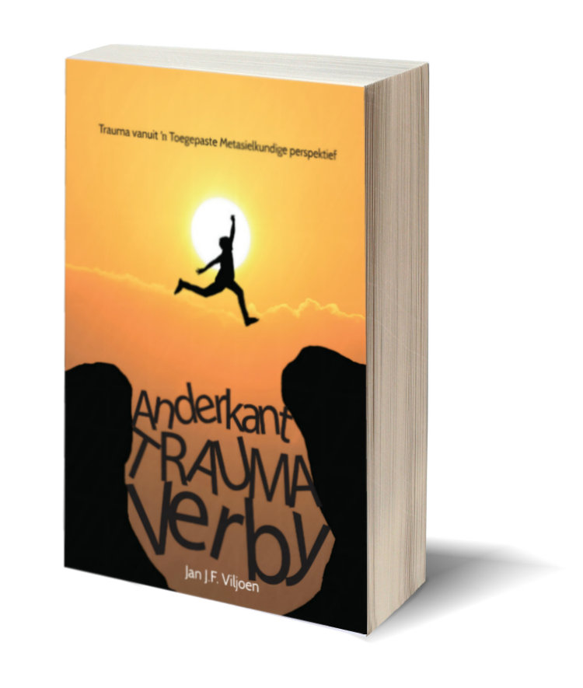
TWEEDE Uitgawe
Met sy boek "Anderkant Trauma verby", maak Jan Viljoen 'n nuwe benadering tot die hantering van Trauma toeganklik vir terapeute, beraders en predikante. Dit bring hoop vir die slagoffers van Trauma. Hoop vir vinnige, effektiewe verligting van die onaangename nagevolge van traumatiese ervarings.

Jan put uit sy ryk ervaring as militêre kapelaan en, na sy aftrede, as berader. In die verlede was hy, soos so baie ander hulpverleners, dikwels magteloos om werklik die getraumatiseerde mens - slagoffers van plaasmoorde, verkragtings, motorkapings, gewapende rooftogte ens - voor hom, te help.

In hierdie boek deel hy sy huidige diep bevrediging in sy werk en die bron daarvan, met die leser. Nou kan hy sy kennis van "Traumatic Incident Reduction (TIR) en ander Toegepaste Metasielkunde tegnieke, wat hy aan die leser verduidelik, effektief gebruik in sy hulpverlening aan slagoffers van Trauma en ander negatiewe belewenisse.

Hierdie is werklik 'n boek vir sy tyd.
Yvonne Retief.

Die eerste boek in Afrikaans oor TIR en ander Toegepaste Metasielkundige tegnieke.

- 12 Hoofstukke

- 181 Bladsye

- Die noodsaaklikheid om beraders vir trauma te bemagtig

- Uitgebreide inligting oor trauma

- Die vestiging van TIR en ander praktiese Metasielkundige tegnieke in SA

- Historiese oorsig oor Metasielkunde

- Kommunikasie tegnieke

- Opleiding en Akkreditasie

- Etiek

- Skuldgevoelens

- Plaasaanvalle

- Aangrypende Trauma stories

- Bronne vir verdere lees

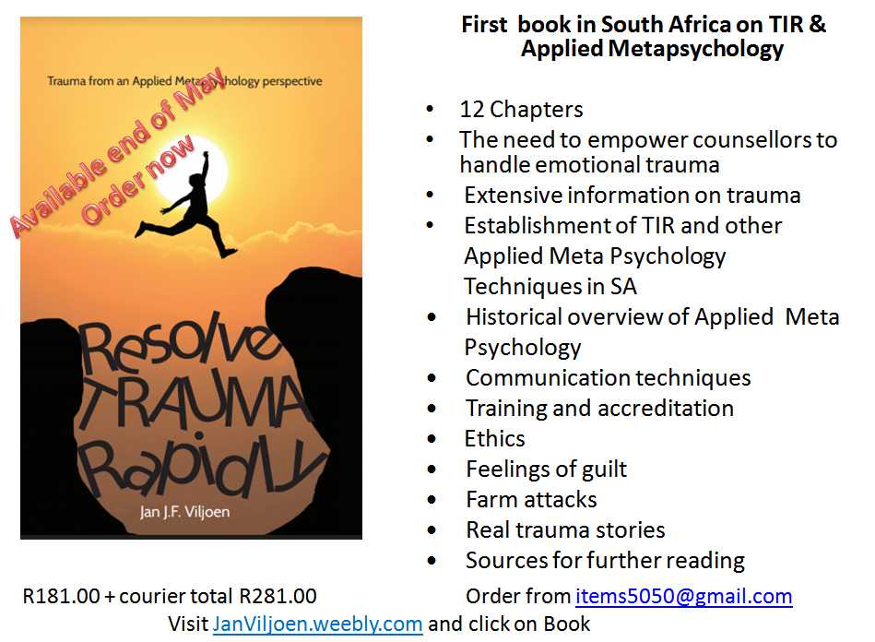

Order form (Type/Print please)

Anderkant Trauma Verby

Trauma Resolved Rapidly

Title Initials
& Surname :
Address for delivery:
Postal code
Province
Mobile number
Email address

Payment - Please EFT to my account & email Proof of payment with this completed to: items5050@gmail.com

Account holder: JJF Viljoen
Bank: ABSA
Type: Check
Account Number: . 2050 920 014
Branch mall@reds
Branch code: 632005
Reference: . Your initials & surname

South African orders only. For foreign orders please email me.

1 - 6 Books
Number |  |  | Total
 | Afrikaans | R281.00  Koerier ingesluit
 | Epub English &  Afrikaans | R50.00
 | English | R281.00  Courier included

For orders 7 of or more books please contact me.

Orders will be processed after proof of payment reflects in the bank account.

Afrikaanse Kindle e-boek beskikbaar by Amazon

